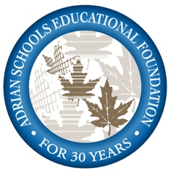

Excellence in Teaching and Mentoring Award

This award recognizes teachers, coaches, administrators and support personnel of APS. The Awards Committee may choose to recognize those who demonstrate excellence in teaching, deliver creative and quality instruction or serve as outstanding role models that inspire and motivate students. These awards are intended to recognize and reward those APS employees who go above and beyond the normal expectations and who have significantly and positively changed the lives of students.

Criteria:
- Instill in students a desire to learn and to achieve
- Encourage students to develop into contributing citizens
- Understand individual student needs, encourage talents and foster self-esteem
- Have been an Adrian Public School employee for a minimum of 3 years
- Be employed by Adrian Public School at the time of the nomination
- Have not received the award within the previous four years

Award:
- Up to a $2,000 stipend for as many as 3 employees annually.

Nomination Process:
- It is preferred that students nominate the recipients for these awards, however, alumni and parents/ guardians of current or past students are also welcome to submit nominations.
- Complete a nomination form and submit to the Adrian Schools Educational Foundation Office by the
deadline date of June 8, 2020.
- Files of unsuccessful nominees shall be retained by the ASEF for possible reconsideration for up to three years
- Adrian Public School employees may not submit nominations, however, employees may write letters of
support for nominees.
- Individuals may not nominate members of their immediate family (grandparents, parents, brothers, sisters, children).
- Nominators and supporters of the nominee may be personally contacted by the Award Committee.

Selection Process:
- Recipients will be chosen by an Awards Committee consisting of three representatives chosen by the Adrian Schools Educational Foundation trustees and two representatives appointed by the grantor. Awards are made at the sole discretion of the Awards Committee. The Award Committee is a subcommittee of the Adrian Schools Educational Foundation and is not directly connected to Adrian Public Schools.

Publicity
- Requests for nominations will be publicized through the school system district and school newsletters, area media, web sites and alumni newsletters/mailing.

Award Presentation:
- When: Homecoming Week, Thursday, October 15, 2020, in conjunction with the Outstanding Adrian High School Alumni Awards. Details will be announced at a later date.

2008 Recipients: Sharon Sauter (Alexander), Kathy Engardio (AHS), Tom Thiery (AHS)
2009 Recipients: Annie Howard (Elem Art), Lisa Eddy (AHS), Claudia Wallace (AHS Adm. Asst.) 2010 Recipients: Julianne Dolan (Fine Arts Director), Bill Esterline (Coach), Dallas Marvin (AMS 7-8) 2011 Recipients: Deb Risner (Michener), Phil Jacobs (AHS), Kelly Armstrong (Alexander)
2012 Recipients: Dawn Huggins (Lincoln), Cammy DiPietro (AMS 7-8), Ryan Bills (AHS)
2013 Recipients: Michaeleen Williams (Alexander), Dawn Jackson (AHS), Dan Kesterke (AMS 7-8, AHS)
2014 Recipients: Jill Roberts (Lincoln), Cheryl Cook, (Michener), Denee Hartung (AMS 7-8 Bldg)
2015 Recipients: Jim Rubley (APS), Jeff Condon (Alexander), Elaine Kaiser (AHS)
2016 Recipients: Sara Holtz (Prairie), Amy Bahlau AMS 7-8, Sandra Humphries (AMS 7-8)
2017 Recipients: Jeff Petterson (Alexander), Tracy Hribar (AHS), Monica Adams (AHS)
2018 Recipients: Doug Ruesink (Adrian Community High School), Marie Lucius (AHS), Thomas Allor (AHS),
2019 Recipients: Mari Alvarez (Lincoln), Jason Lucius (AHS), Tanya Smith (AHS)

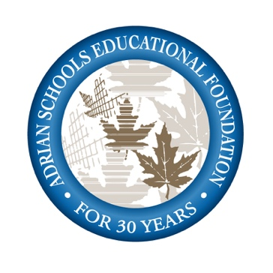
Excellence in Teaching and Mentoring Award
NOMINATION FORM
Please type or print legibly

To be submitted by June 8, 2020

Section 1: Information on nominee and nominator

I'm nominating (print employee's name): Current APS employee assignment (school/department if known):
Person nominating the employee (print your name):
Current APS Student: Grade School
Parent/Guardian of Current or Former APS Student
Alumnus Friend
My contact information:
Phone: Email:

Section 2: Nomination Narrative (REQUIRED) (A typed submission is preferred.)
Explain why this Adrian Public School employee should be selected for this honor. Give details of your relationship with this employee and how he/she has positively impacted your life or the life of your child. Please use criteria on the preceding explanation page to form your nomination.

Section 3: Supportive Materials (REQUIRED) (A typed submission is preferred.)

Support materials from parents, peers, students, teachers and others must be submitted to help tell your story about how this employee makes a difference in the lives of students. Support material could include letters, memos, videos, news clippings, published articles. While current APS employees may not nominate one another, employees are welcome to submit letters of support for nominees. Attach additional pages of support materials.

I verify that the submitted statements are truthful and accurate to the best of my knowledge and that I am not an immediate family member of the employee I am nominating.

Signature of Nominator Date submitted

The completed Nomination Form should be submitted through mail or in person by June 8, 2020, to:
Adrian Schools Educational Foundation
785 Riverside Ave, Suite 2
Adrian, MI 49221
ASEF@adrian.k12.mi.us
---------------------------------------------------------------------------------------------------------------------------------------------------------

Office Use: Date Received
In Person Mailed

